Nursery Home Learning - Week beginning 8/2/21
I can’t wait to see the learning that you have done! Please upload it to Tapestry where possible.
Daily recorded phonics sessions will be available for you to access via our website and Tapestry.

Story of the Week
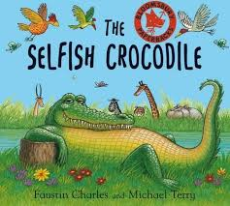
https://www.youtube.com/watch?v=0-NhjfJ_RZI

Monday | Literacy activity: Watch the story. Upload a video to Tapestry of you retelling the story. Why do you think the crocodile was selfish/didn’t want to share? Have you ever felt like this? When?  Also, practice writing your name.
Tuesday | Fine Motor activity: Try weaving around cardboard. Use wool, thread or string to weave around a cardboard shape. It could be a square, circle or any other shape of your choosing. Tie the end around the card before you start!  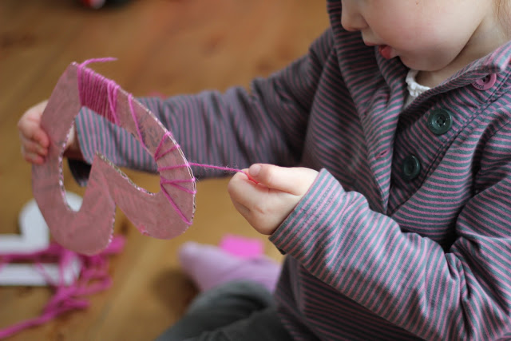
Wednesday | PSHE activity:The crocodile had a bad tooth. What he may have done for it to get so bad? What do you need to do to look after your teeth? E.g. brushing for 2 minutes twice a day, avoiding sugary foods/drinks, drinking water etc. Count how many teeth you have. Make a mouth with teeth in:  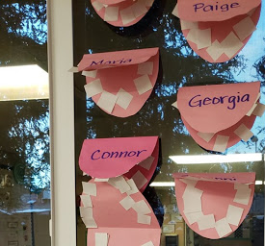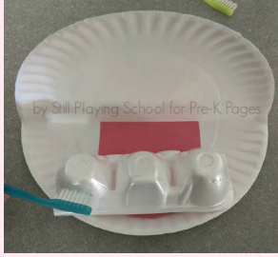
Thursday | EAD activity: Make a model of a crocodile.  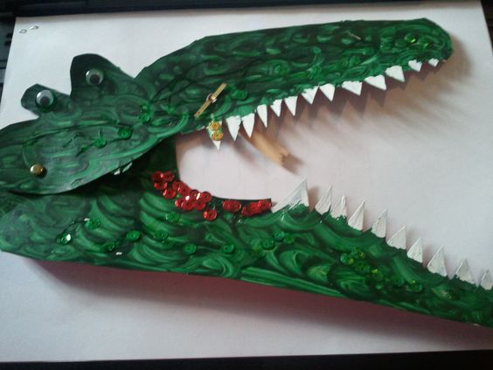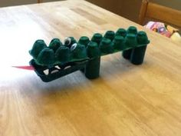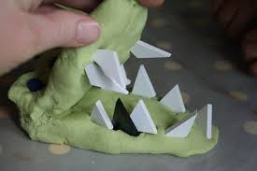  When you’ve finished, sing this crocodile counting song:  https://www.youtube.com/watch?v=LwE2kjyQ5kY
Friday | RE activity: What does Jesus teach Christians? Christians believe that through his stories and actions, Jesus teaches them about God and the way they should behave. He said that one thing was more important than everything else. What do you think this is? Listen to this link and find out: https://www.youtube.com/watch?v=3as1QIC832w  The most important thing is love. Draw all the people things you love and get an adult to scribe what they are underneath.

